Task 1 – Containerization

Step 1: Create a sample Node.js app

Create a folder in the name of node-sample-app and move into that folder

Create a file in the name of server.js and package.json

Paste the below mentioned content in the respective files.

server.js:

const express = require("express");
const app = express();

app.get("/", (req, res) => {
res.send("Node.js App running inside Docker!");
});

const port = process.env.PORT || 3000;
app.listen(port, () => console.log(`App running on port ${port}`));

package.json:

{
"name": "node-sample-app",
"version": "1.0.0",
"main": "server.js",
"scripts": {
"start": "node server.js",
"test": "node test.js"
},
"dependencies": {
"express": "^4.17.1"
}
}

Step 2: Create a multi-stage Dockerfile

This is production-ready and best practice.

Dockerfile:

# ---- Build Stage ----
FROM node:18-alpine AS builder
WORKDIR /app

COPY package*.json ./
RUN npm install --only=production

COPY . .

# ---- Runtime Stage ----
FROM node:18-alpine
WORKDIR /app

COPY --from=builder /app /app

EXPOSE 3000

CMD ["npm", "start"]

Step 3: Build the Docker image locally:

docker build -t maheshdevops/node-sample-app:v1 .

Step 4: Run the container locally:

docker run -d -p 3000:3000 maheshdevops/node-sample-app:v1

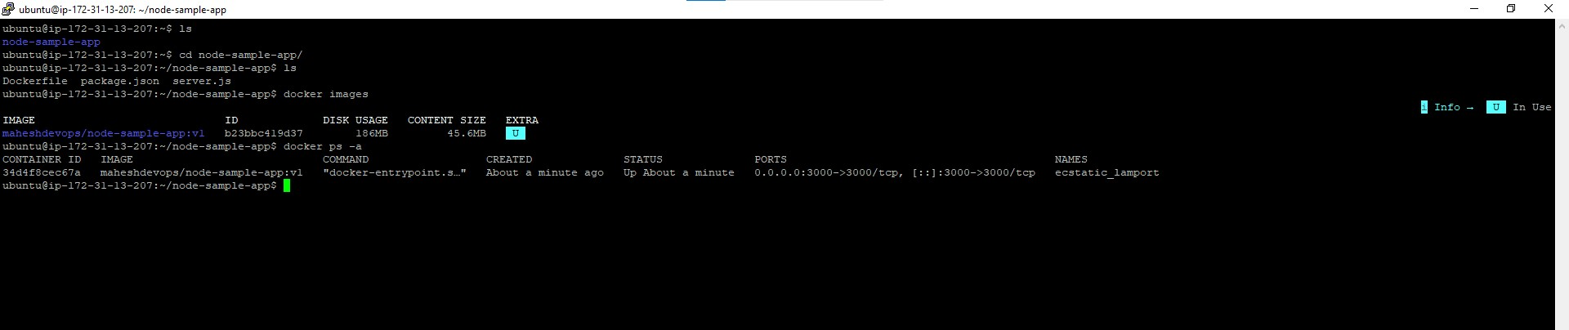

Test in browser using the ip with port:

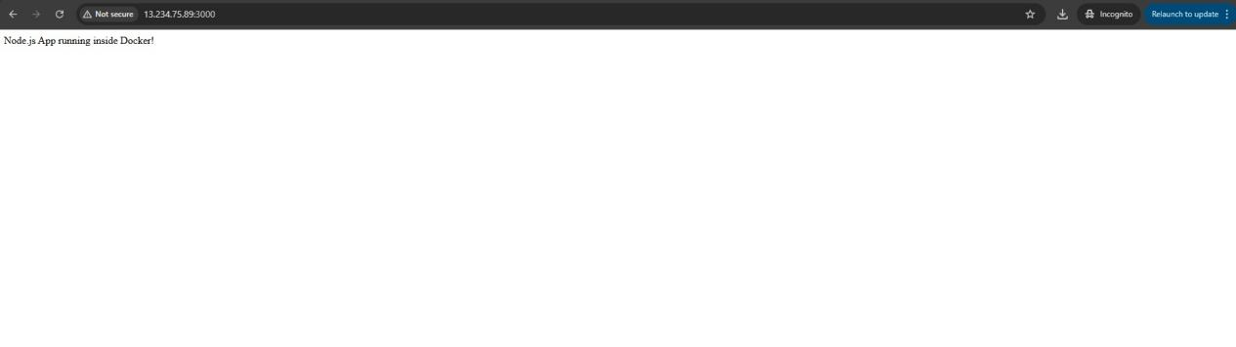
Step 5: Push the image to DockerHub:

Login into the docker hub using docker login command

Tag the image

Push the image to the docker hub

